Setting up the E-Gym VTAP NFC/RFID Reader

Issue
Customer has the E-Gym Integration with EVOLT but need to properly setup the VTAP Reader
- Customer turns the unit off using the power switch
- Have the customer plug in the VTAP Reader to one of the 4 USB Ports behind the screen
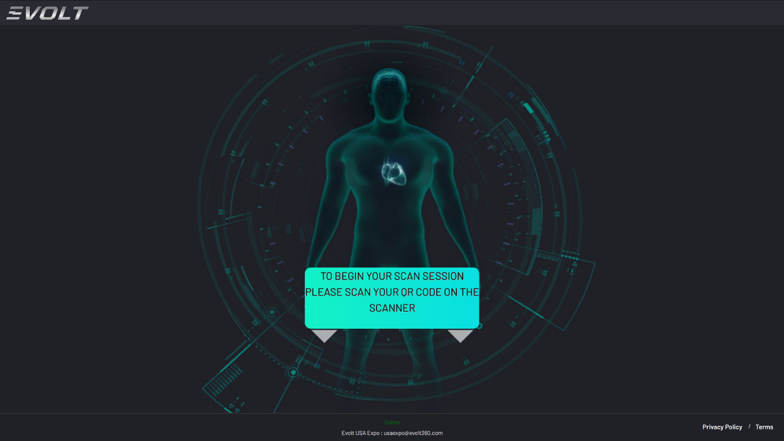
- Customer will then power the unit on, and the screen should appear differently than the normal Home Screen:
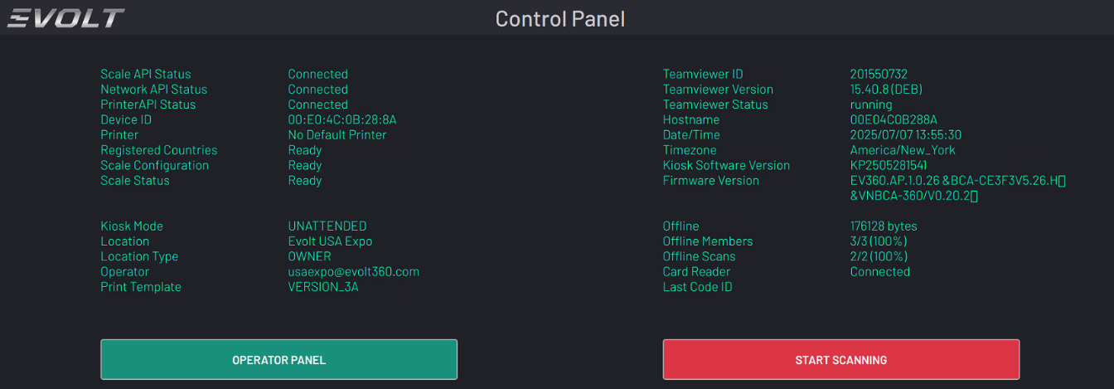
- If you do not see this screen; return to the Control Panel and check that the Software version is updated; and that the Card Reader Status shows “Connected”
- If the Software version is outdated of 30 or more days; run a software update to ensure the latest version is installed.
- If the card reader is disconnected; but the VTAP is plugged into the unit; you can either reboot the unit via the power switch; or
  - Restart all services if you can TeamViewer into the unit by typing the following into the command terminal:
    - sudo supervisorctl restart all
  - If the card readers still reads disconnected check to ensure that the USB lock is not turned on.
    - Check the USB lock in SYSTEM settings; if it’s “ON”, turn it off and power cycle the unit or:
      - If you can TeamViewer into the unit run the command:
        - sudo supervisorctl restart all
- If the card reader still is not being picked up; test the USB Ports with another device to determine if the PCB Board is defective or if the VTAP reader is defective; escalate to the EVOLT Team if no devices work in any of the USB ports.

